**PROJECT REPORT**

On

“Static Website Hosting using AWS

S3,Cloudfront,Route 53,Certificate Manager”

*Submitted in partial fulfilment of the requirements for the award of*

**Bachelor of Technology (B.Tech)**

In the department of

**Computer Science & Engineering** 

*Submitted by*:

RUPAM GOGOI **(CSE)**

MD. SHAH NAWAZ UDDIN **(CSE)**

PALLAB DEBROY**(CSE)**

BHASKAR JYOTI HAZARI **(ECE)**

ANKUR GOGOI **(EE)**

*Under the Guidance of:*

Mr.Pranav Kumar(**Internal Mentor**)

**(Assistant Professor,CSE dept.)**

**External Mentor**

Pradeep Sir

**( IBM )**

**School of Engineering & Technology**

**The Assam Kaziranga University, Jorhat, Assam**

**Nov –2020**

**ACKNOWLEDGEMENT**

It brings us great pleasure for an opportunity to work and submit our project report on **Static Website Hosting in AWS S3**.For this we are deeply indebted and sincerely thankful to our University and IBM.

We would like to express our sincere gratitude to our internal mentor **Prof. Pranav Kumar** for providing his invaluable guidance, comments and suggestions throughout the duration of our project.

We would also like to thank our external mentor **Pradeep sir** from IBM for motivating us to work harder.

**ABSTRACT**

This project aims to develop,deploy,manage a static website on Amazon Web Services (AWS) using services like S3,cloudfront for improving quality of service,Route 53,Certificate Manager while keeping operational simplicity and business requirements in mind.We are also using an approach that provides 1) insignificant cost of operation, 2) little or no management required, and 3) a highly scalable, resilient, and reliable website.

**Aim of the project:**

To host a Static Website Hosting using AWS S3,Cloudfront,Route 53,Certificate Manager.

**Problem Statement:**

As enterprises become more digital operations, their websites span a wide spectrum, from mission-critical e-commerce sites to departmental apps, and from business-to business portals to marketing sites. Factors such as business value, mission criticality, service level agreements , quality of service, and information security drive the choice of architecture and technology stack.

The simplest form of website architecture is the static website, where users are served static content (HTML, images, video, JavaScript, style sheets, and so on). Static websites are straightforward in one sense, but they can still have demanding requirements in terms of scalability, availability, and service-level guarantees. For example, a marketing site for a consumer brand may need to be prepared for an unpredictable onslaught of visitors when a new product is launched.

**To see the project live:**

Go to the below link:

<https://healthy-bites.tk/>

**Understanding of the Project:**

**Static Website:**

A static website delivers content in the same format in which it is stored. No server-side code execution is required. For example, if a static website consists of HTML documents displaying images, it delivers the HTML and images as-is to the browser, without altering the contents of the files. Static websites can be delivered to web browsers on desktops, tablets, or mobile devices. They usually consist of a mix of HTML documents, images, videos, CSS style sheets, and JavaScript files. Static doesn’t have to mean boring—static sites can provide client-side interactivity as well. Using HTML5 and client-side JavaScript technologies such as jQuery, AngularJS, React, and Backbone, we can deliver rich user experiences that are engaging and interactive.

Some examples of static sites include:

• Marketing websites

• Product landing pages

• Microsites that display the same content to all users

• Team homepages

portfolios

**.** A website that lists available assets (e.g., image files, video files, and press releases) allows the user to download the files as-is

• Proofs-of-concept used in the early stages of web development to test user experience flows and gather feedback .

Static websites load quickly since content is delivered as-is and can be cached by a content delivery network (CDN). The web server doesn’t need to perform any application logic or database queries. They’re also relatively inexpensive to develop and host. However, maintaining large static websites can be cumbersome without the aid of automated tools, and static websites can’t deliver personalized information. Static websites are most suitable when the content is infrequently updated. After the content evolves in complexity or needs to be frequently updated.

**WORKFLOW OF THE PROJECT:**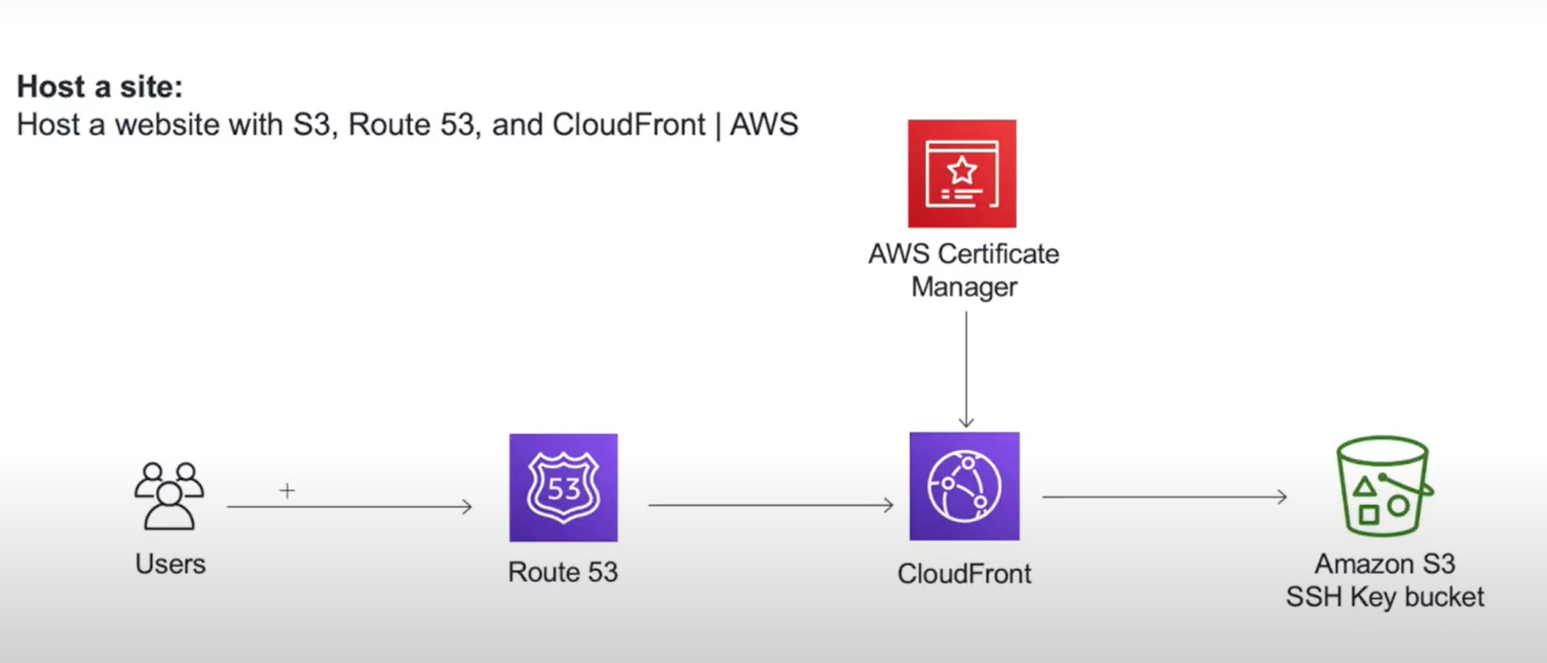

All of our website content are stored in S3 bucket.Now if a user goes to our domain name then Route 53 will route the user to the cloudfront distribution.Then next AWS certificate manager will provide the HTTPs certificate .Once that is done the cloud front will reach to the S3 bucket and serve the content to the user.

**Technology Stack - Application Development Architecture:AWS**

**1.AWS:**

Amazon web service is a platform that offers flexible, reliable, scalable, easy-to-use and cost-effective cloud computing solutions.

AWS is a comprehensive, easy to use computing platform offered by Amazon. The platform is developed with a combination of infrastructure as a service (IaaS), platform as a service (PaaS) and packaged software as a service (SaaS) offerings.

**2.AWS S3:**

Amazon Simple Storage Service (Amazon S3) is an object storage service that offers industry-leading scalability, data availability, security, and performance. This means customers of all sizes and industries can use it to store and protect any amount of data for a range of use cases, such as data lakes, websites, mobile applications, backup and restore, archive, enterprise applications, IoT devices, and big data analytics. Amazon S3 provides easy-to-use management features so you can organize your data and configure finely-tuned access controls to meet your specific business, organizational, and compliance requirements. Amazon S3 is designed for 99.999999999% (11 9's) of durability, and stores data for millions of applications for companies all around the world.

3.**Cloudfront:**

Amazon CloudFront is a fast content delivery network (CDN) service that securely delivers data, videos, applications, and APIs to customers globally with low latency, high transfer speeds, all within a developer-friendly environment. CloudFront is integrated with AWS – both physical locations that are directly connected to the AWS global infrastructure, as well as other AWS services. CloudFront works seamlessly with services including AWS Shield for DDoS mitigation.

4**.Route 53:**

Amazon Route 53 is a highly available and scalable cloud Domain Name System (DNS) web service. It is designed to give developers and businesses an extremely reliable and cost effective way to route end users to Internet applications by translating names like www.example.com into the numeric IP addresses like 192.0.2.1 that computers use to connect to each other. Amazon Route 53 is fully compliant with IPv6 as well.

4.**Certificate Manager:**

AWS Certificate Manager is a service that lets you easily provision, manage, and deploy public and private Secure Sockets Layer/Transport Layer Security (SSL/TLS) certificates for use with AWS services and your internal connected resources. SSL/TLS certificates are used to secure network communications and establish the identity of websites over the Internet as well as resources on private networks. AWS Certificate Manager removes the time-consuming manual process of purchasing, uploading, and renewing SSL/TLS certificates.

5. **HTML:**

**Hypertext Markup Language** (**HTML**) is the standard markup language for documents designed to be displayed in a web browser. It can be assisted by technologies such as Cascading Style Sheets (CSS) and scripting languages such as JavaScript.

Web browsers receive HTML documents from a web server or from local storage and render the documents into multimedia web pages. HTML describes the structure of a web page semantically and originally included cues for the appearance of the document.

6**.CSS**:

Cascading Style Sheets (CSS) is a style sheet language used for describing the presentation of a document written in a markup language such as HTML.CSS is a cornerstone technology of the World Wide Web, alongside HTML and JavaScript.

CSS is designed to enable the separation of presentation and content, including layout, colors, and fonts.This separation can improve content accessibility, provide more flexibility and control in the specification of presentation characteristics, enable multiple web pages to share formatting by specifying the relevant CSS in a separate .css file which reduces complexity and repetition in the structural content as well as enabling the .css file to be cached to improve the page load speed between the pages that share the file and its formatting.

7.**Javascript:**

JavaScript ("JS" for short) is a full-fledged dynamic programming language that can add interactivity to a website. It was invented by Brendan Eich (co-founder of the Mozilla project, the Mozilla Foundation, and the Mozilla Corporation).

JavaScript is versatile and beginner-friendly. With more experience, you'll be able to create games, animated 2D and 3D graphics, comprehensive database-driven apps, and much more.

8.**Jquery:**

jQuery is an open source concise and fast JavaScript library created by John Resig in 2006. The main purpose of jQuery is to make it easy to use JavaScript. It simplifies the interaction between JavaScript and HTML Page. The main motto of jQuery is **Write less, Do more** means jQuery takes a lot of JavaScript code and wraps it into jQuery functions that do the same thing in a single line of code.

**TOOLS USED:**

1.VS CODE

2.CHROME

**BUILDING A STATIC WEBSITE:**

In this project we are building a static website for a food delivery startup which we will be hosting in AWS

We are using HTML for structuring our website and CSS for styling it.We have used javascript library Jquery for adding animation to the site.

We have also made the site responsive for all screen sizes using MediaQuery

**Content of the Website**

* **Homepage Section containing logo and navigation bar.**
* 
* **Food Gallery**
* 
* **How it works section**
* 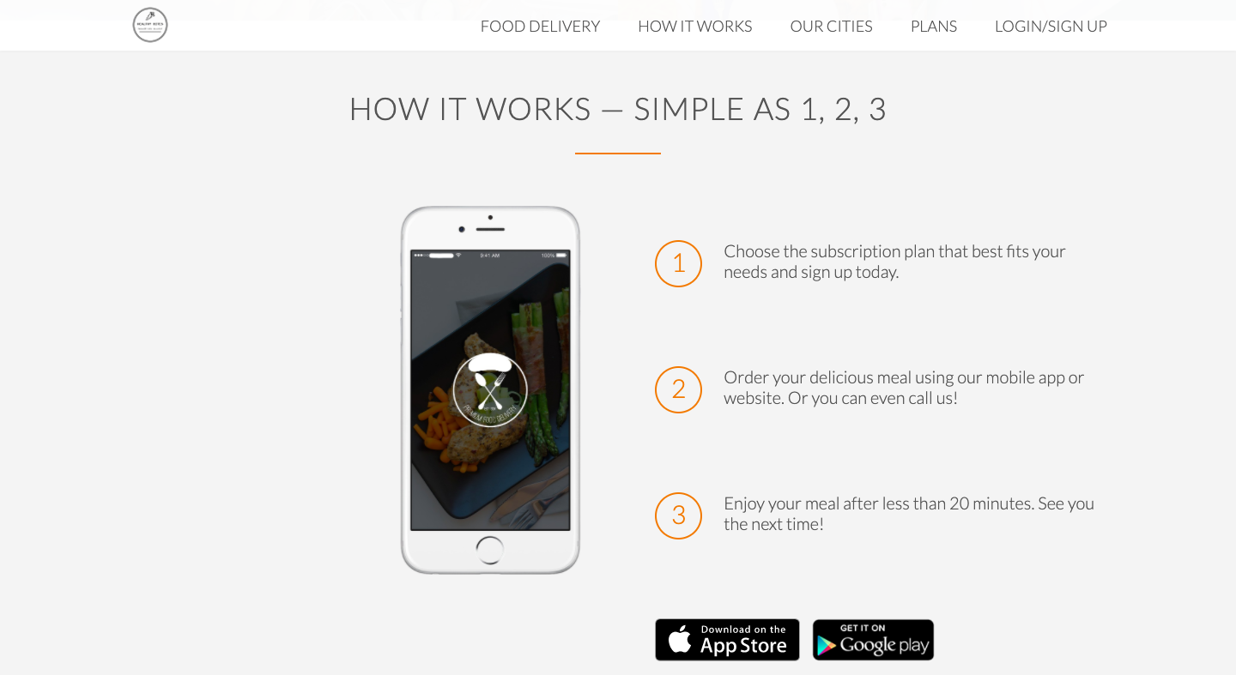
* **Currently available city section**
* 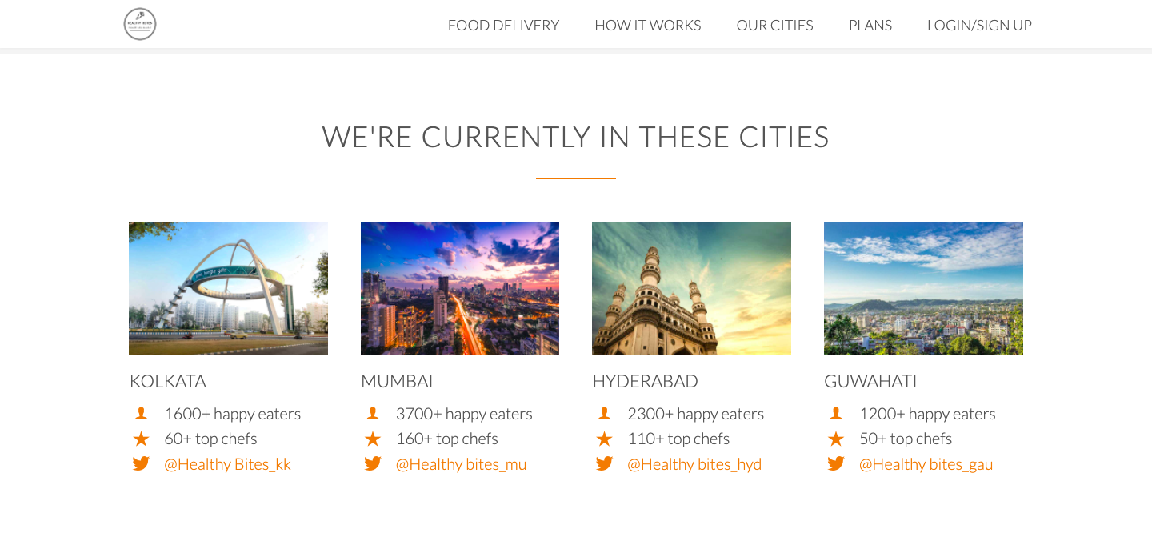
* **Testimonial Section**
* 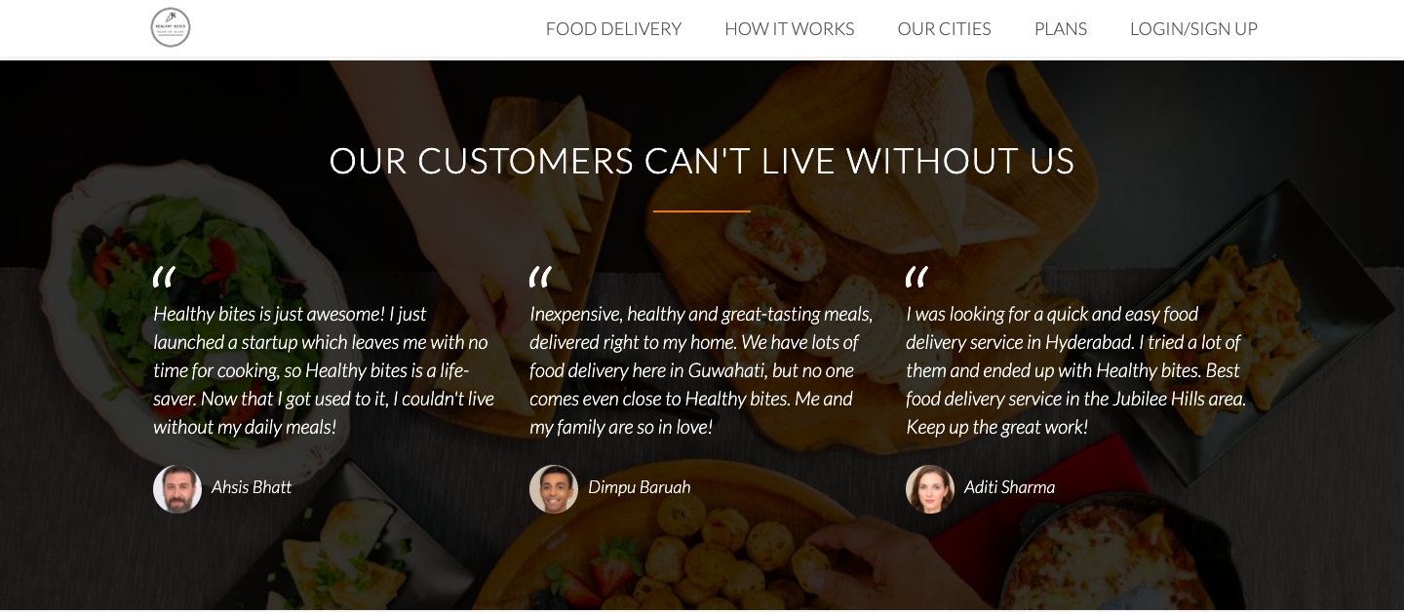
* **Pricing plans section**
* 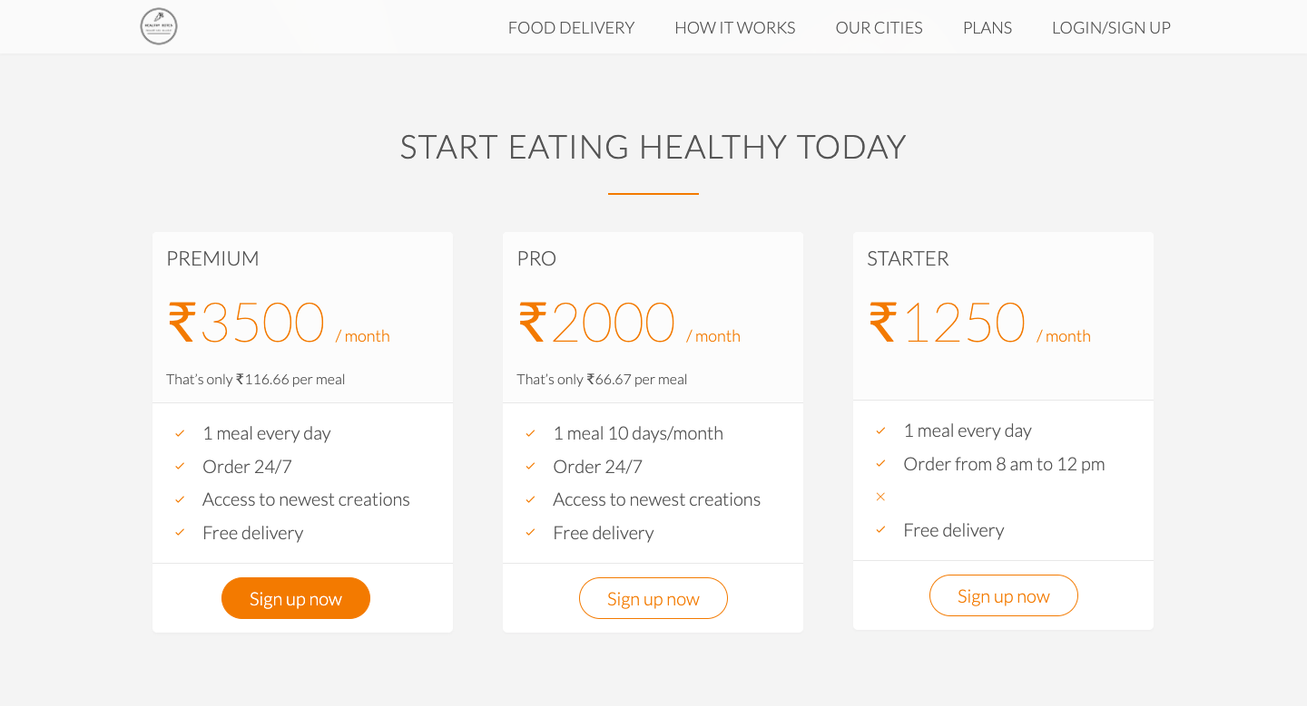
* **Feedback from section**
* 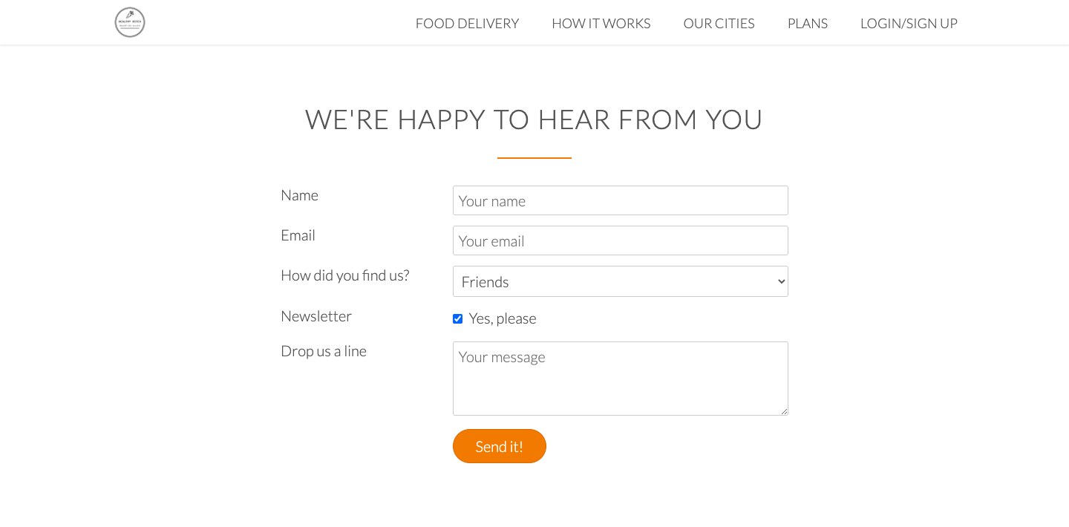
* **Footer**
* 

**Procedure for hosting in AWS:**

1. Register a free domain name from [www.freenom.com](http://www.freenom.comby) by checking the availability and filling the form.

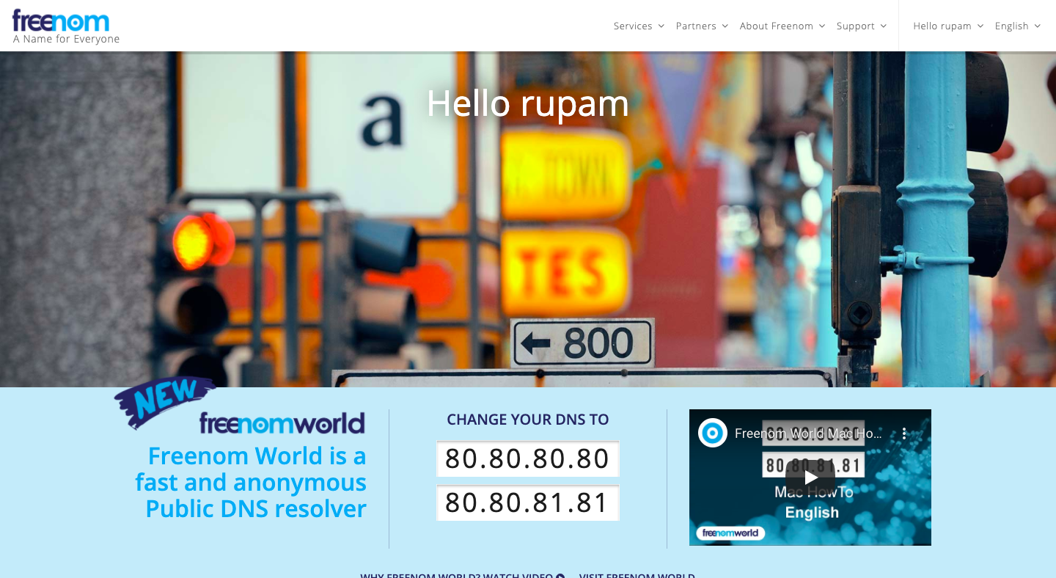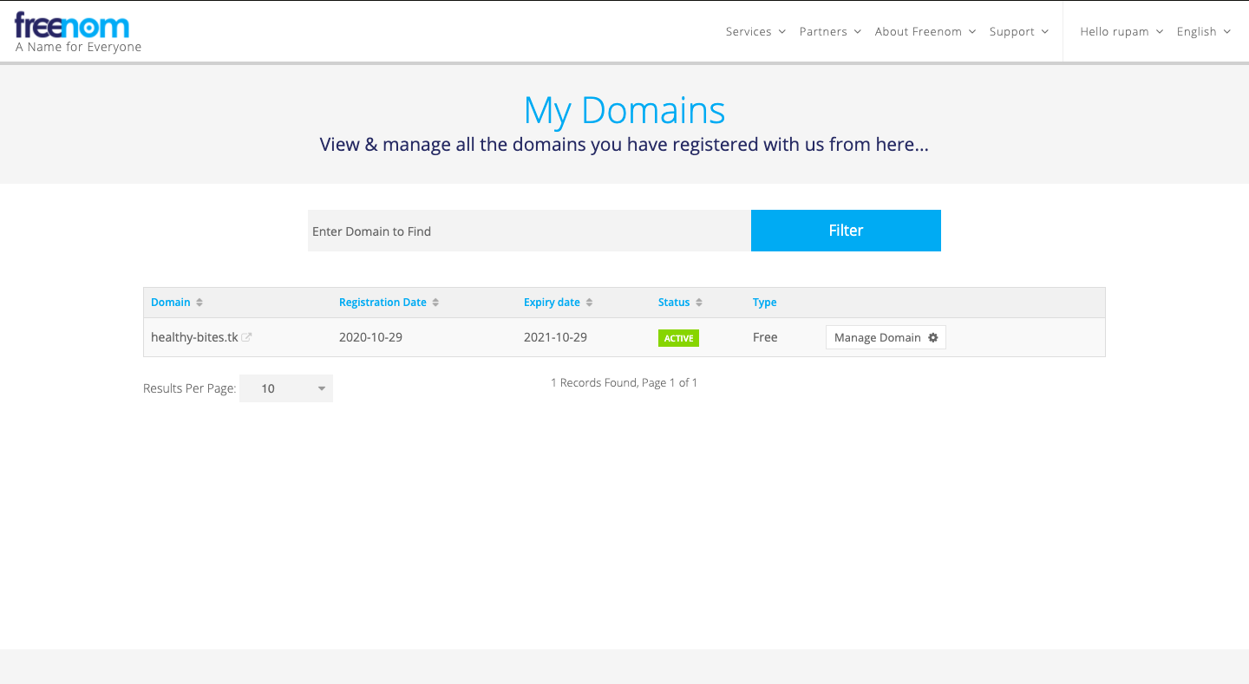

1. Go to aws → S3 → Create a S3 bucket → Upload all the website files(html pages, CSS files) to the bucket .

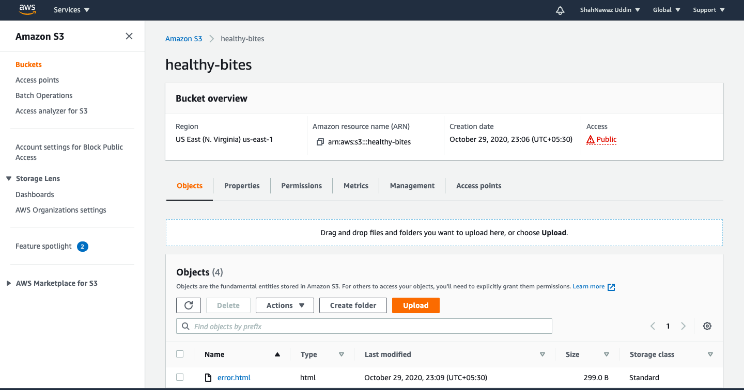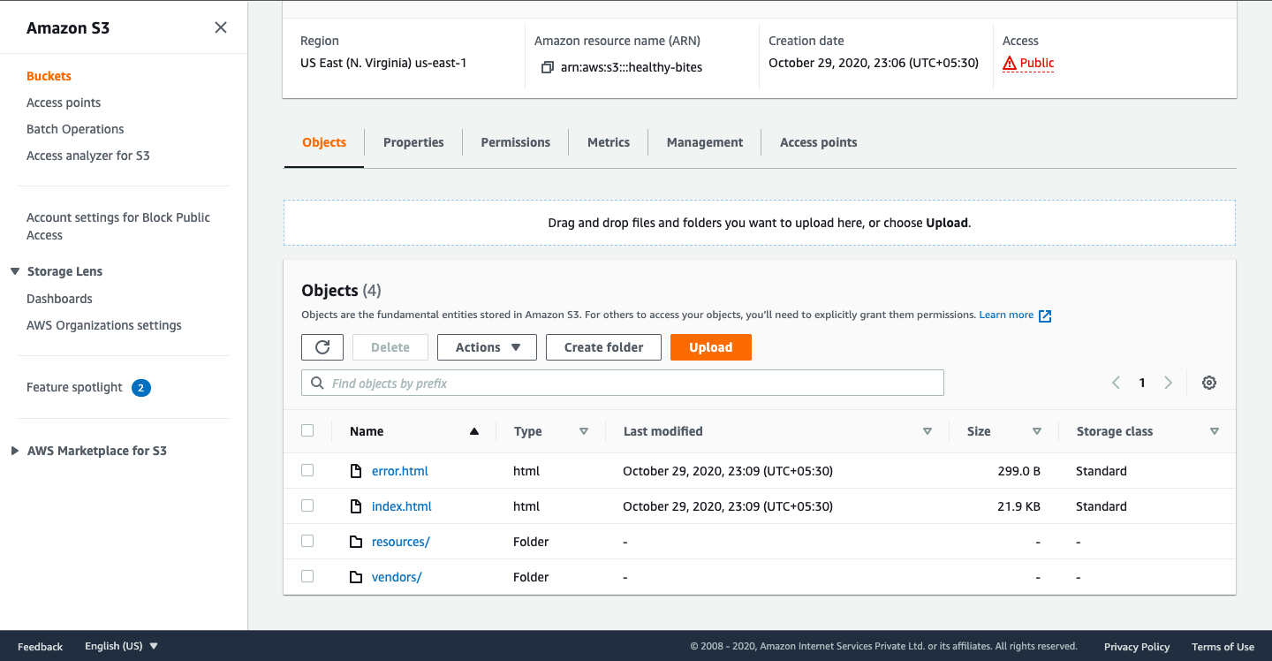

1. Go to permissions → Disable block all public access checkbox → create a bucket policy to make the content of the bucket public as shown in the screenshot.

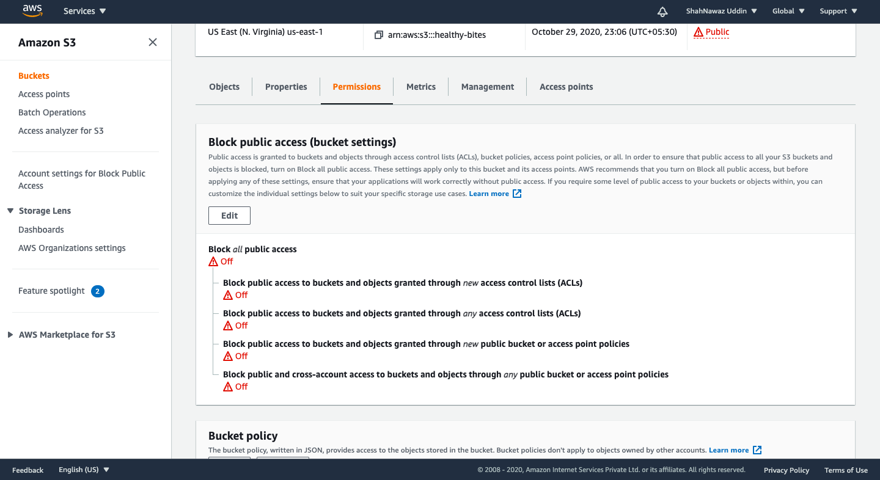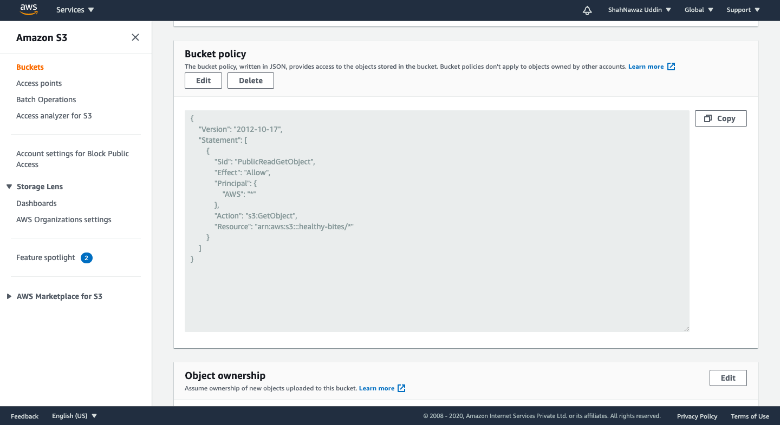

1. Go to the bucket and see if it is showing a label named as public. (If it is showing, then our content inside the bucket is public.) → Then go to properties ---> In there go to static website hosting → Give the index document name as the same name as the main html file.(In our case it is index.html).--> And Give the error document name as the same as the error html file you have created.(which will be shown to the users when the website fails to load).--> save.

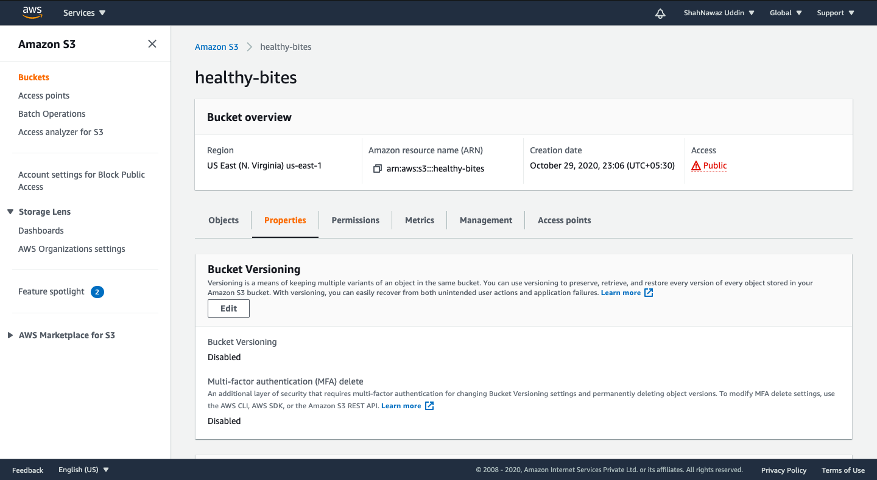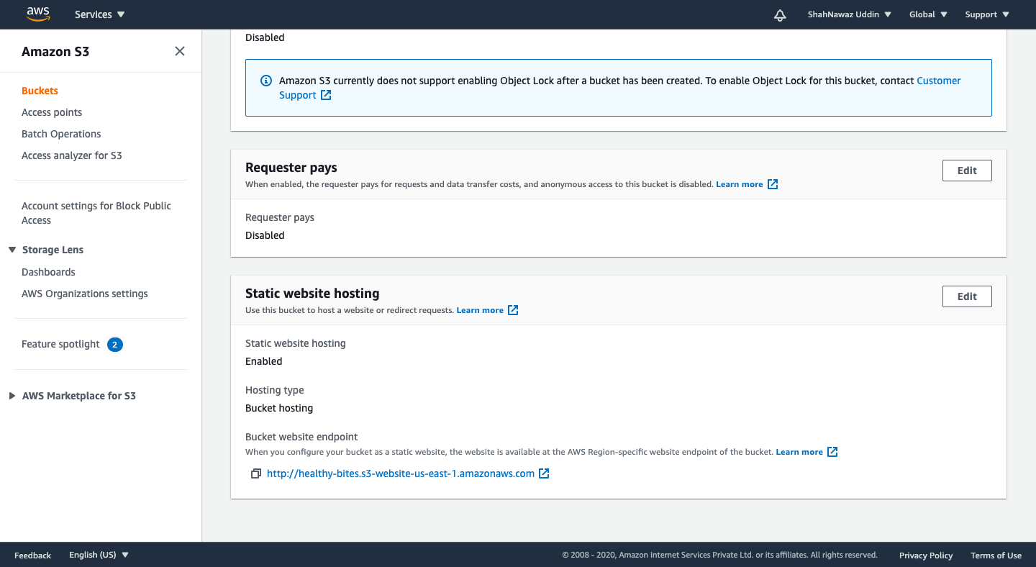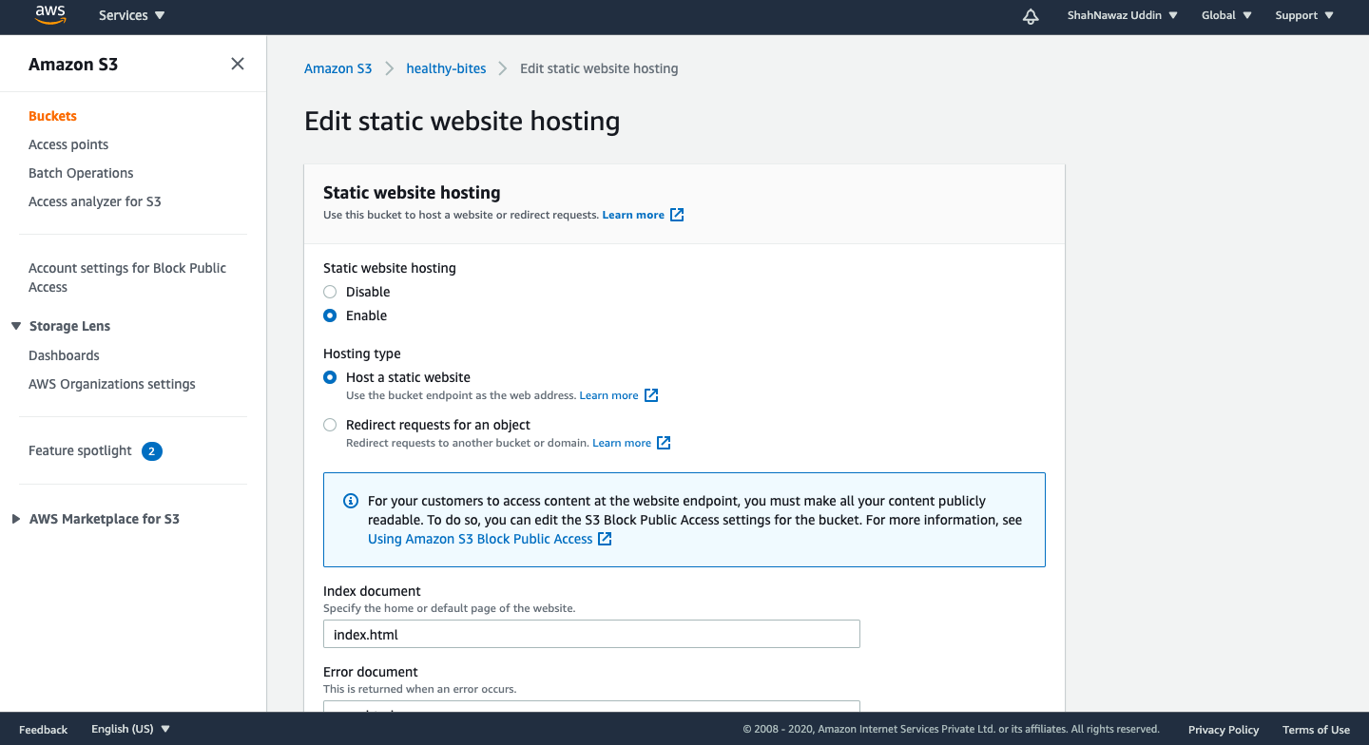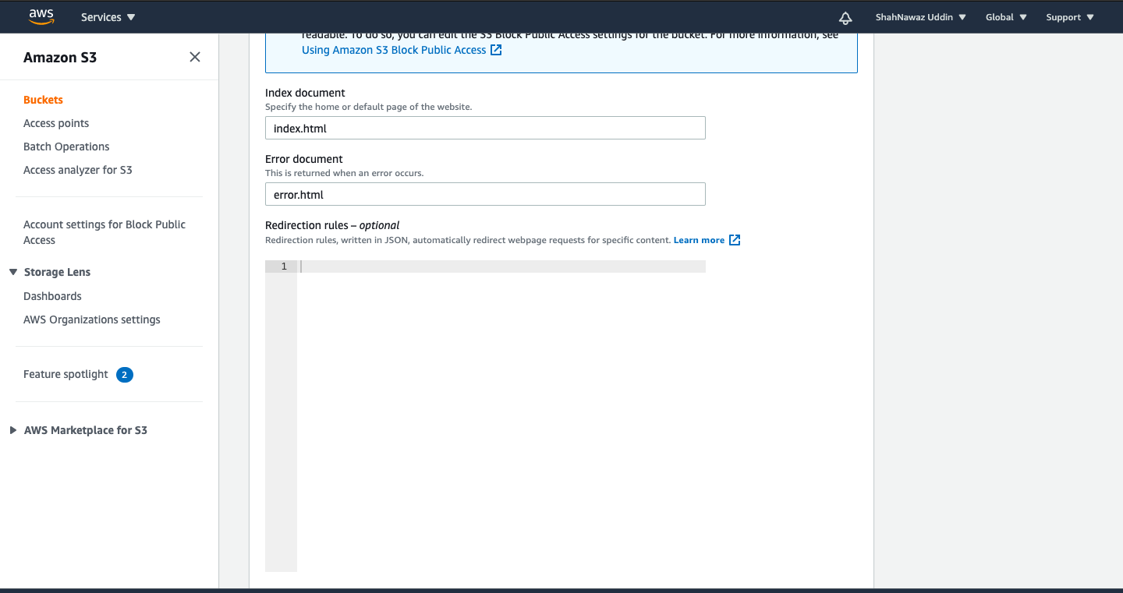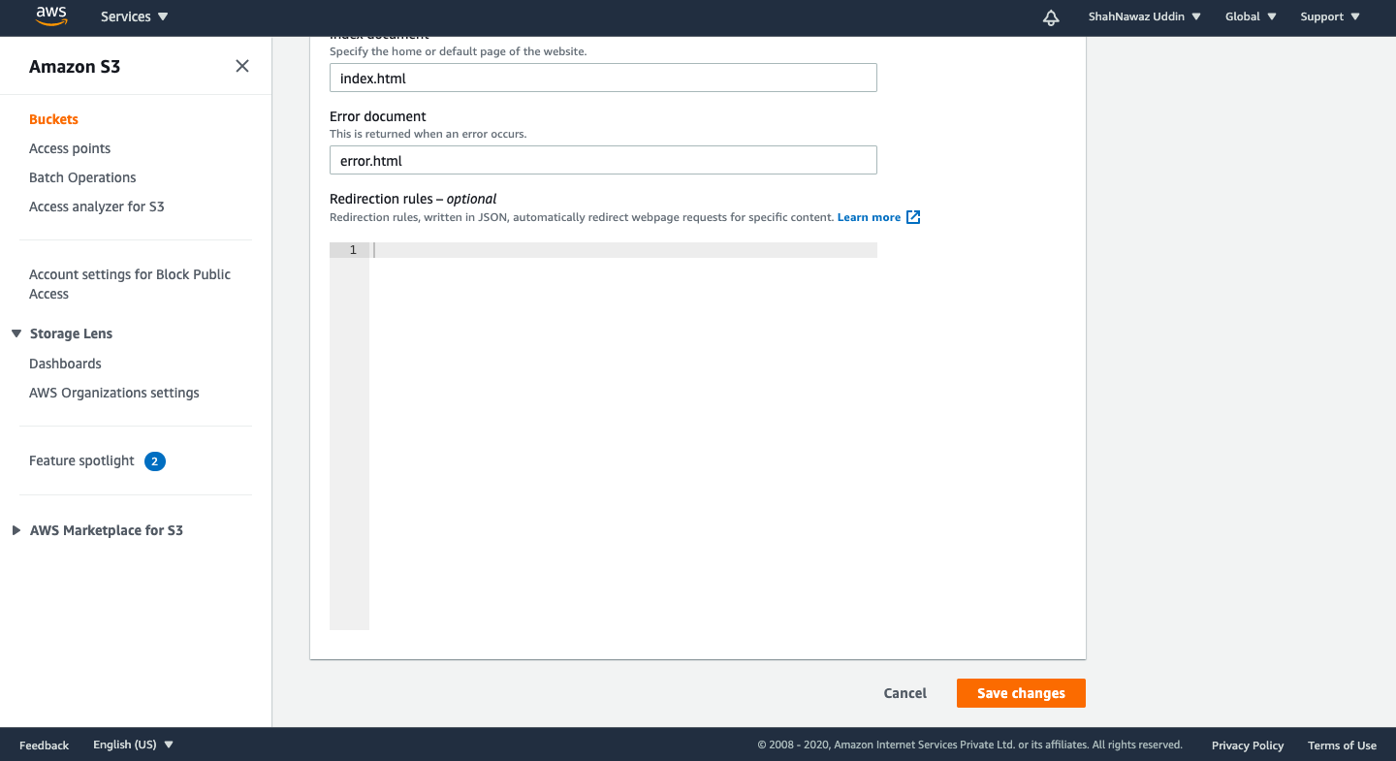

1. To see the website live go to static website hosting again → Click on the endpoint link given there.

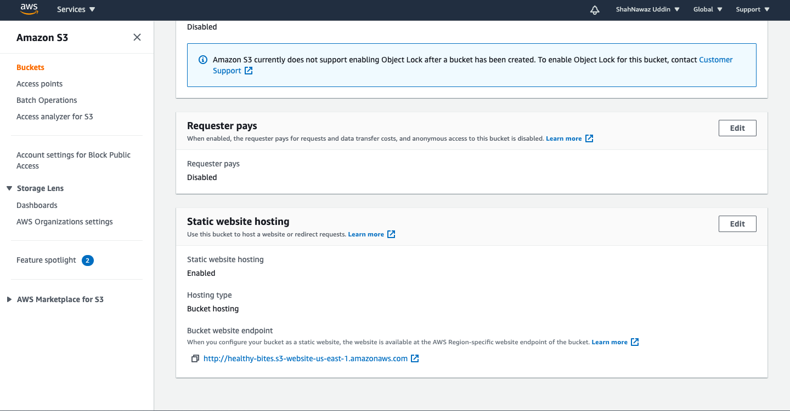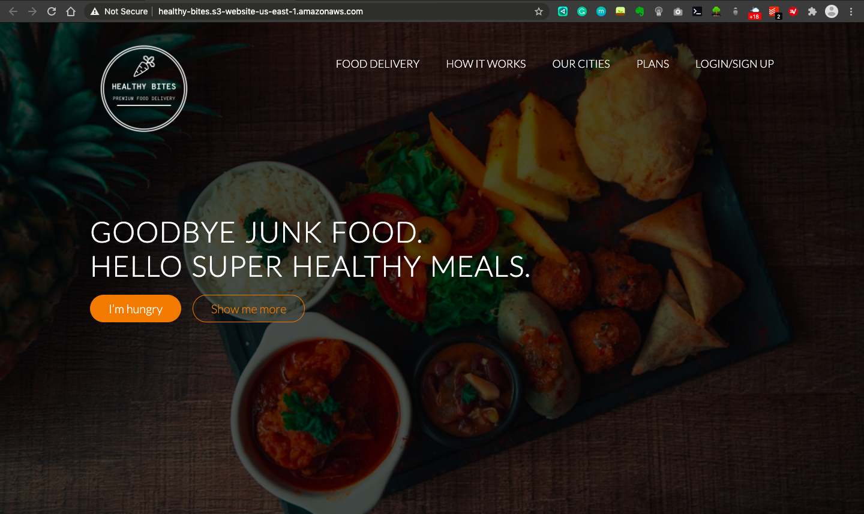

1. To make your website have a custom domain name (That we have registered in freenom) → Go to services in AWS → Route 53(for registering our custom domain name) → Click on create a hosted zone → In there give the domain name as same the freenom domain name that you have created. → Click on create.

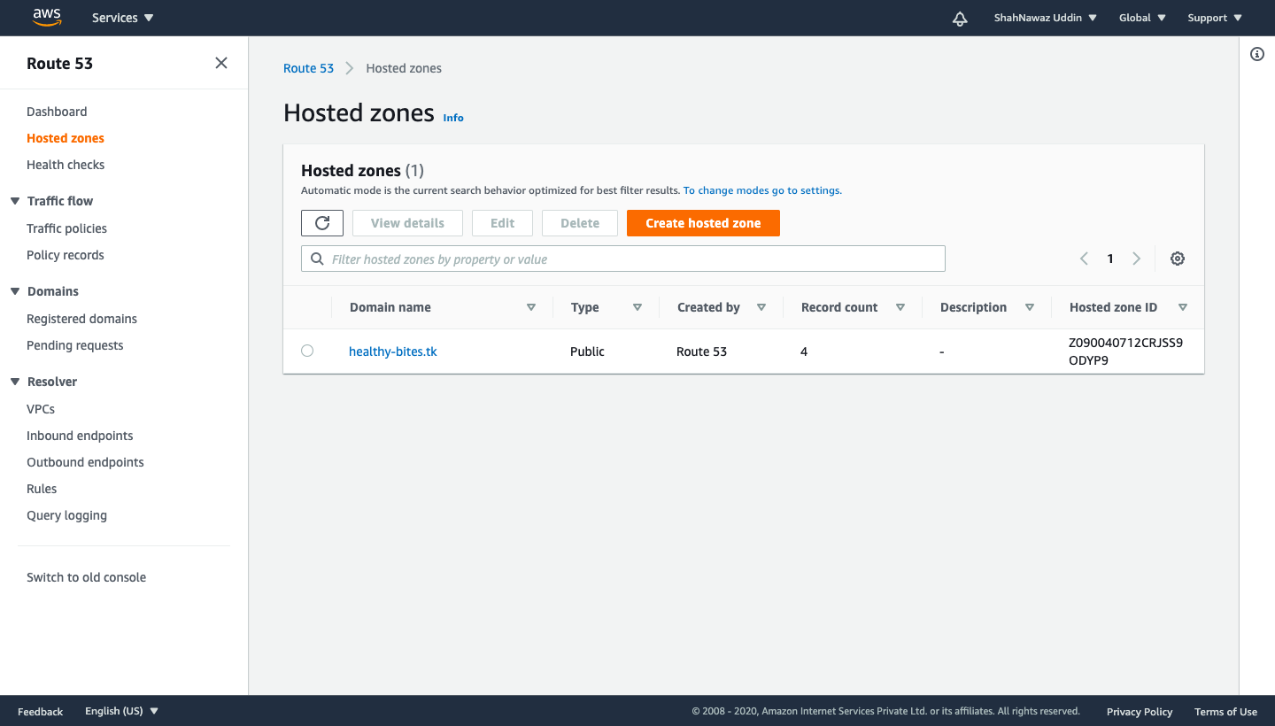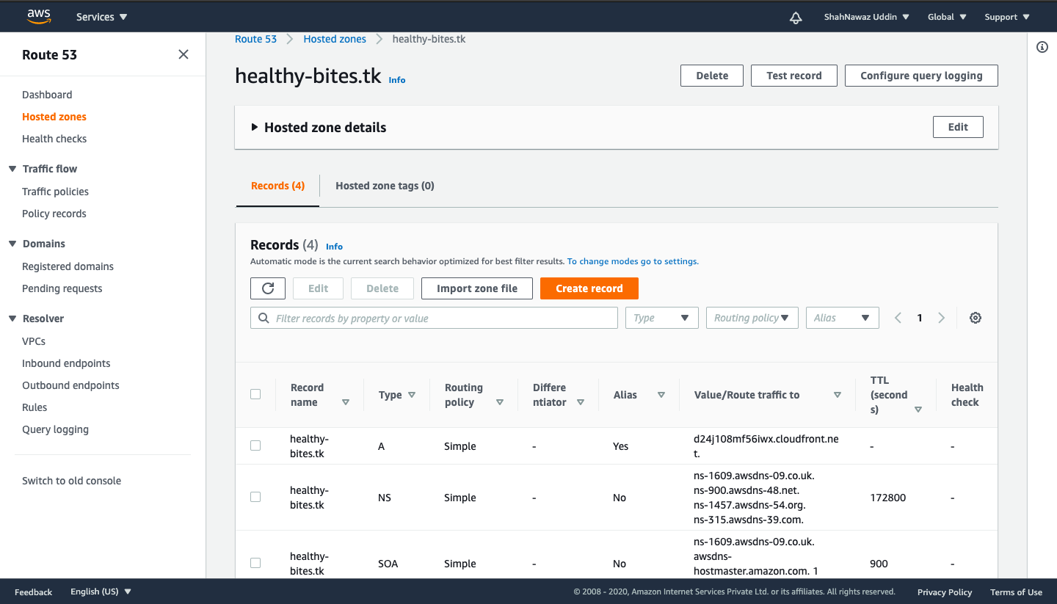

1. Go to freenom website → click on manage domain → click on nameservers→ Choose custom nameserver→ Then go back to the AWS route 53 →Click on tab that says NS→ copy value of the nameservers as shown in the screenshot and paste them one by one in the freenom nameservers field.

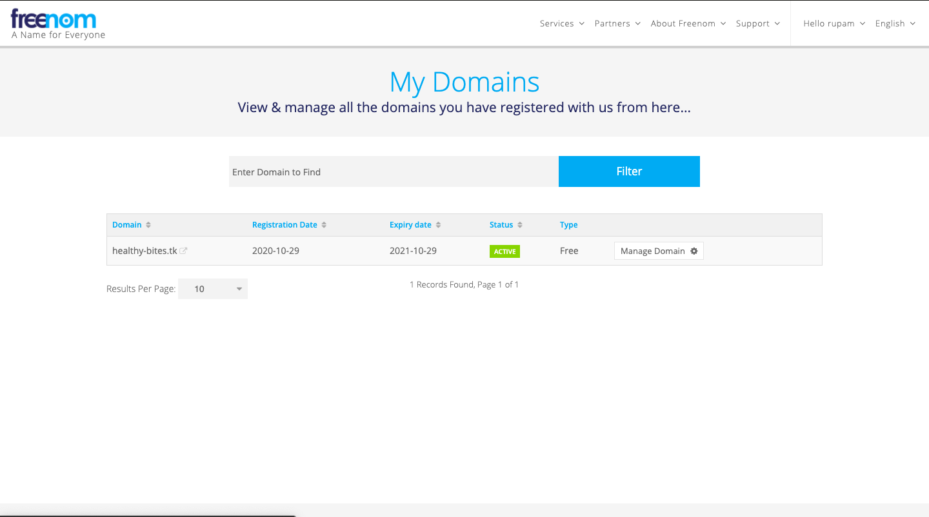

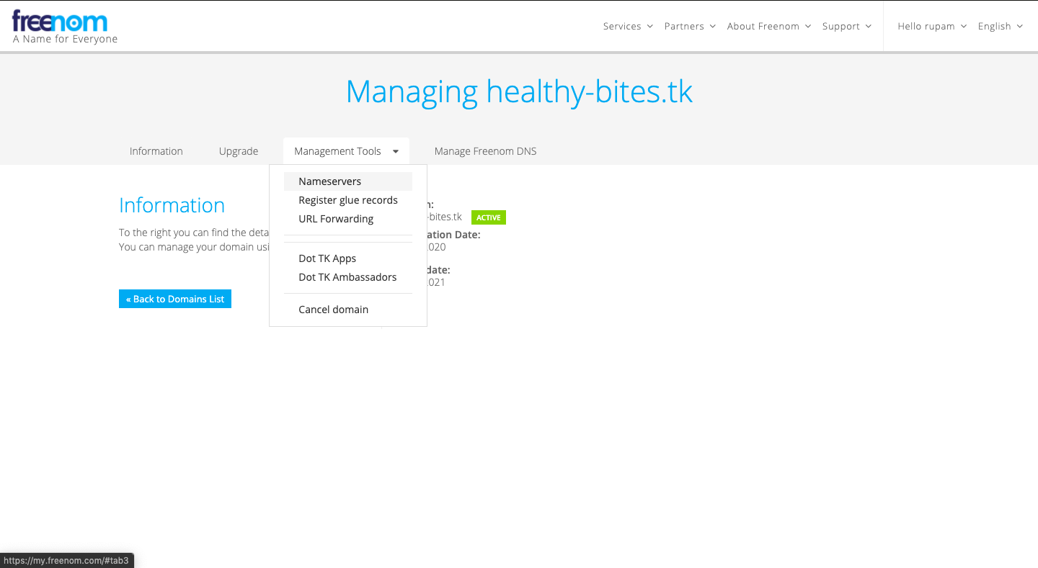

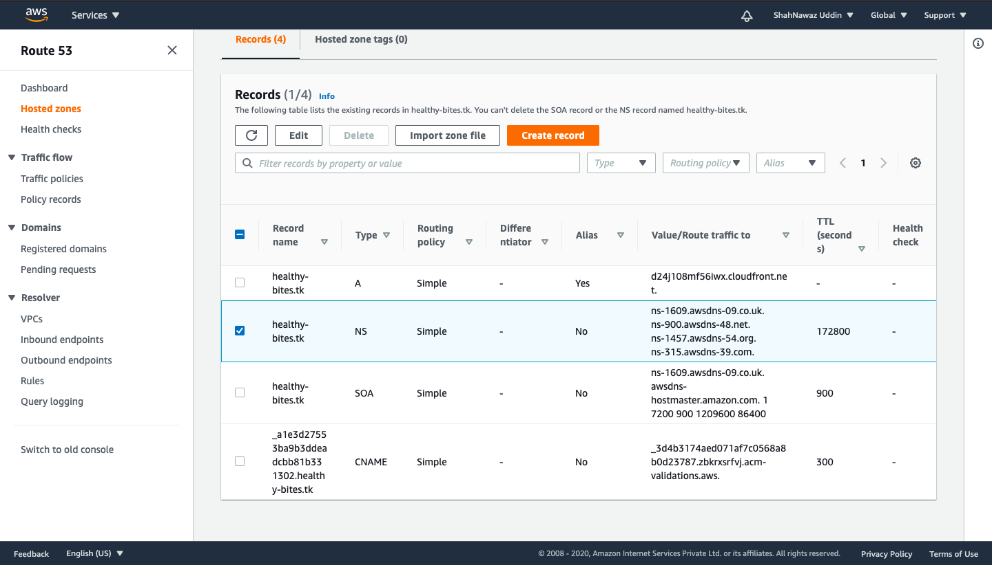

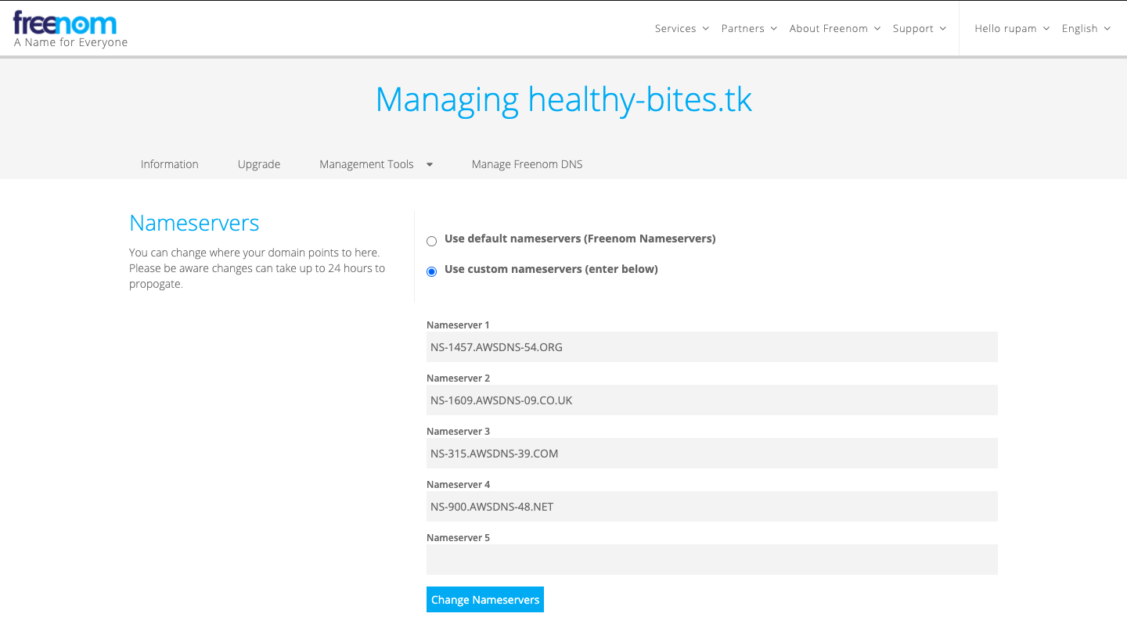

1. To create the SSL certificate using AMAZON certificate manager→ Go to AWS certificate manager → Click on request a certificate → Give the domain name that you have registered in the freenom website→ Click on next→ choose DNS validation→ click continue→ click on Create a record in route 53 → A popup will show up → click create ---> It might take a while to show the status as issued.

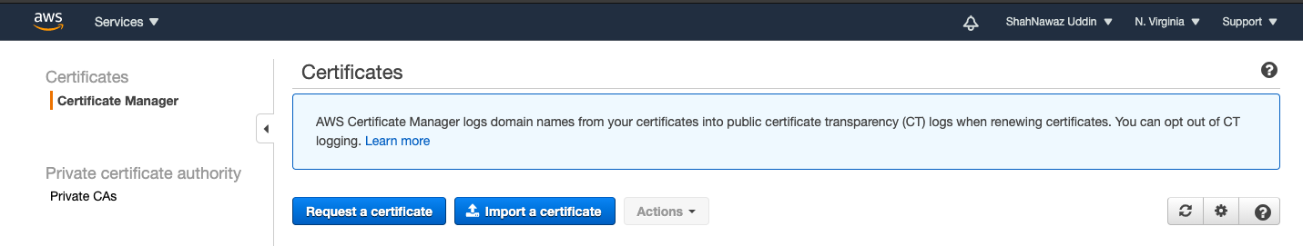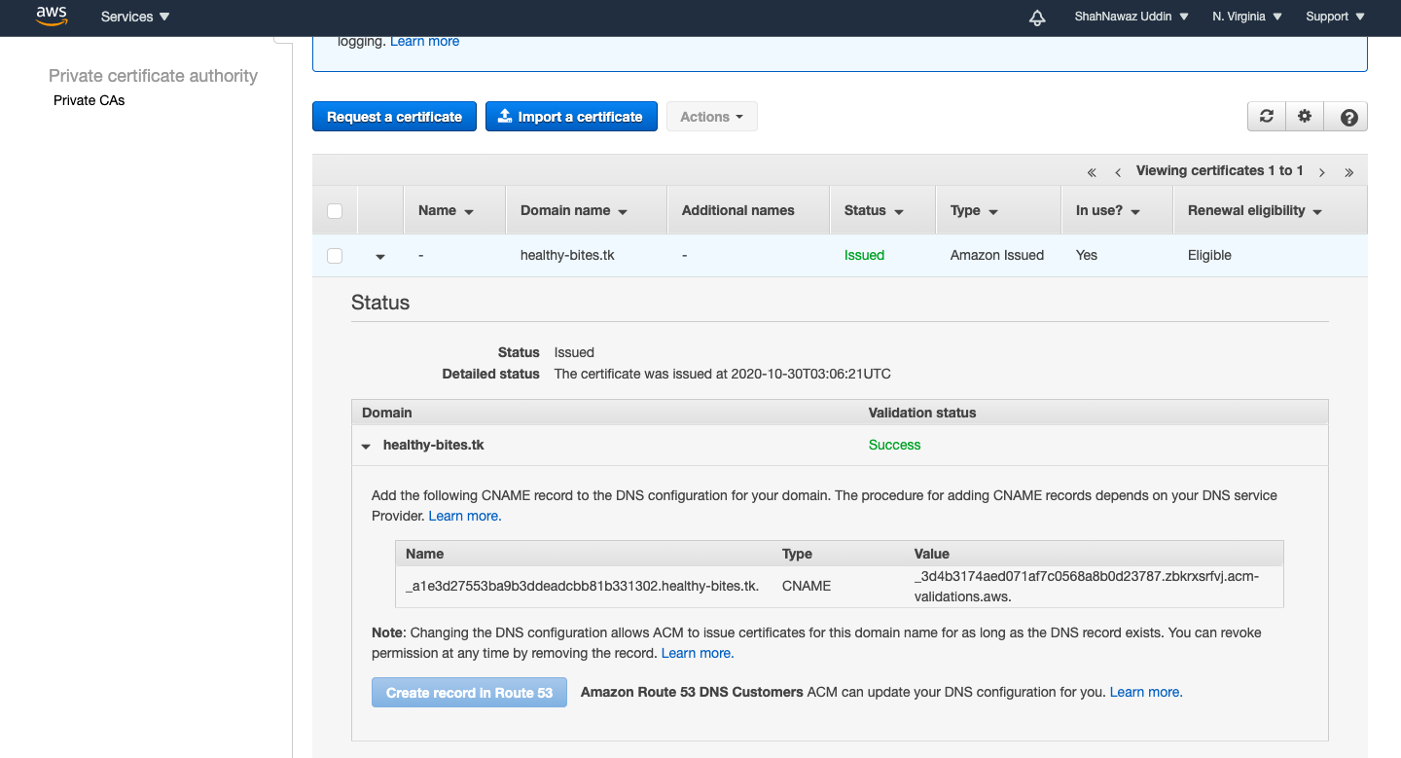

1. To speed up the distribution of our website content we will be using a service named cloudfront in AWS. → Go to cloudfront → Click on create distribution → In there in the origin domain name field give your static website hosting endpoint URL name without http. → Then under the default cache behaviour settings choose redirect http to https→ Under distribution settings section in alternate domain names field, give the domain name as same as in the freenom website. → for choosing a custom SSL certificate see the screenshot given. → Click on create.

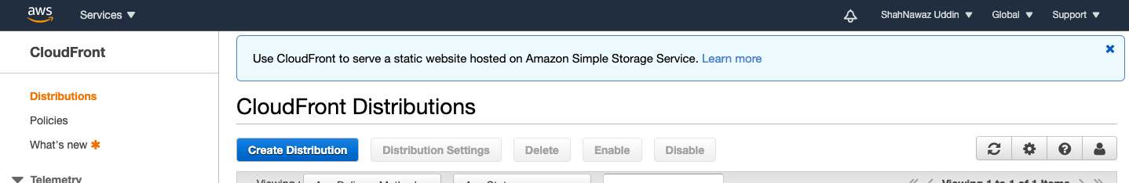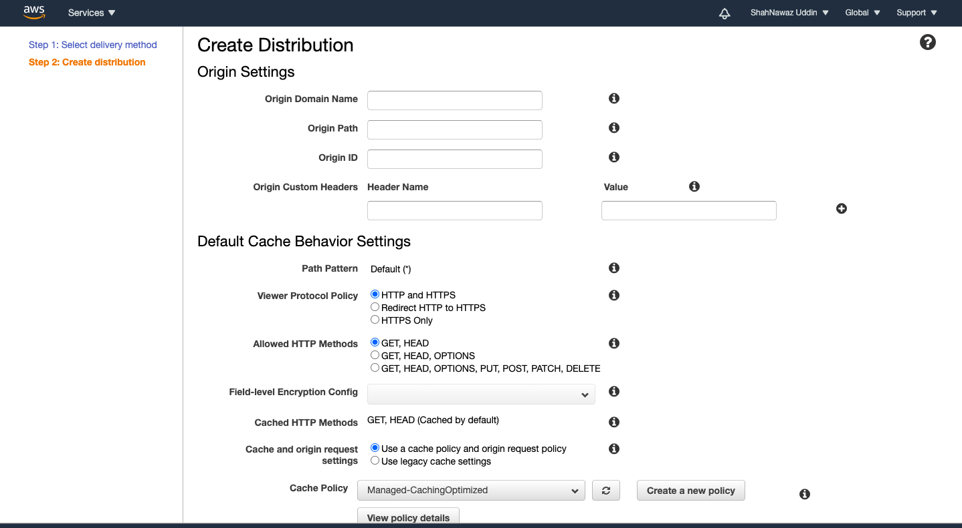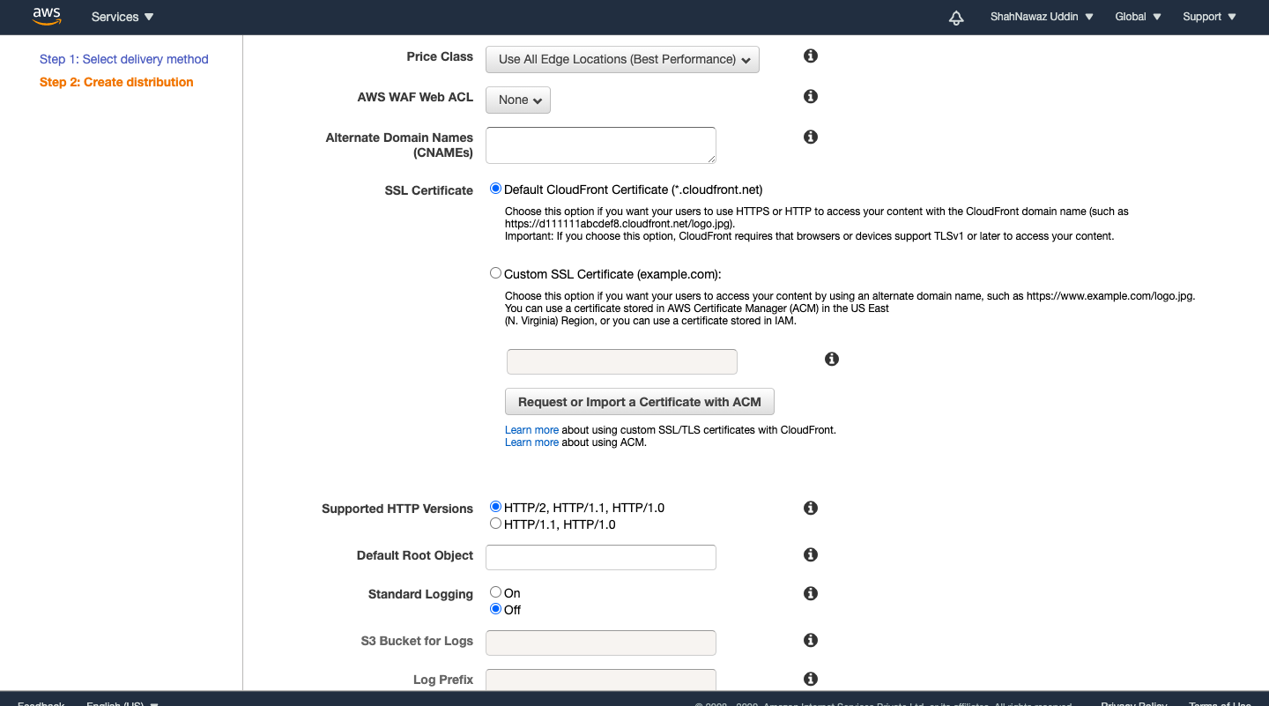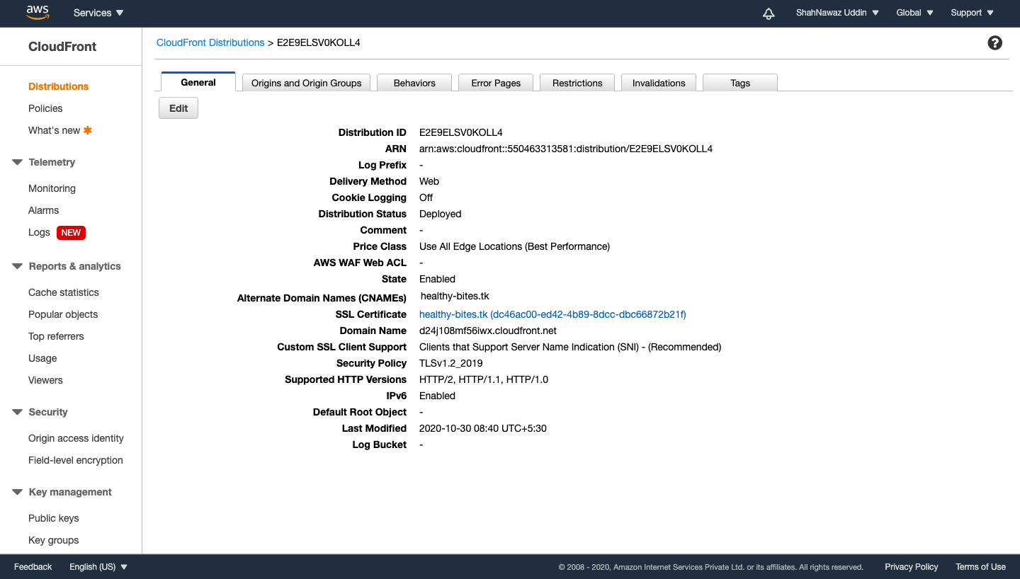

1. It will take some time to show the status of the cloudfront distribution as deployed.

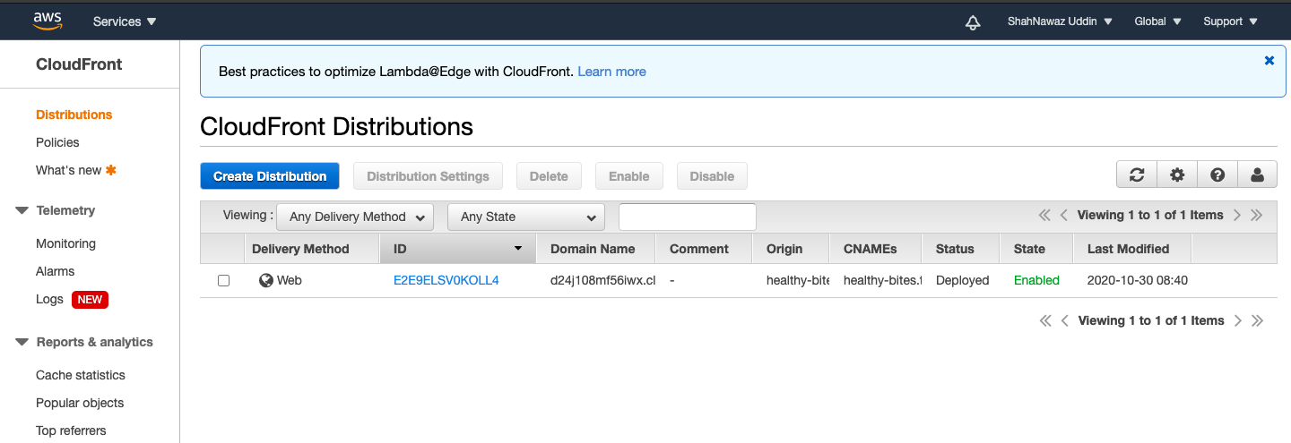

1. To connect your cloudfront distribution with the route 53 → Go back to AWS route 53 → click on domain name → then click on create record set → In there by leaving all other fields as default→ Choose yes on Alias target and choose the target as cloudfront distribution name→ Click on create.

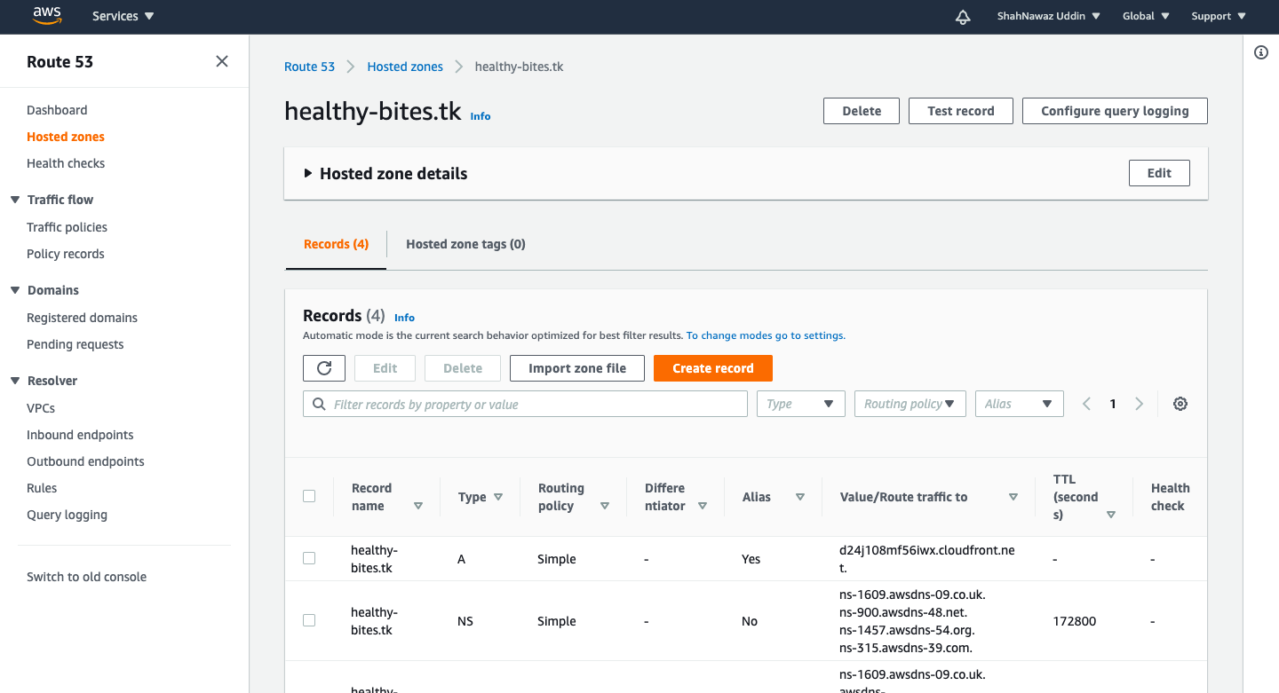

1. Now go to the domain name you have registered with freenom and you are done with hosting it.

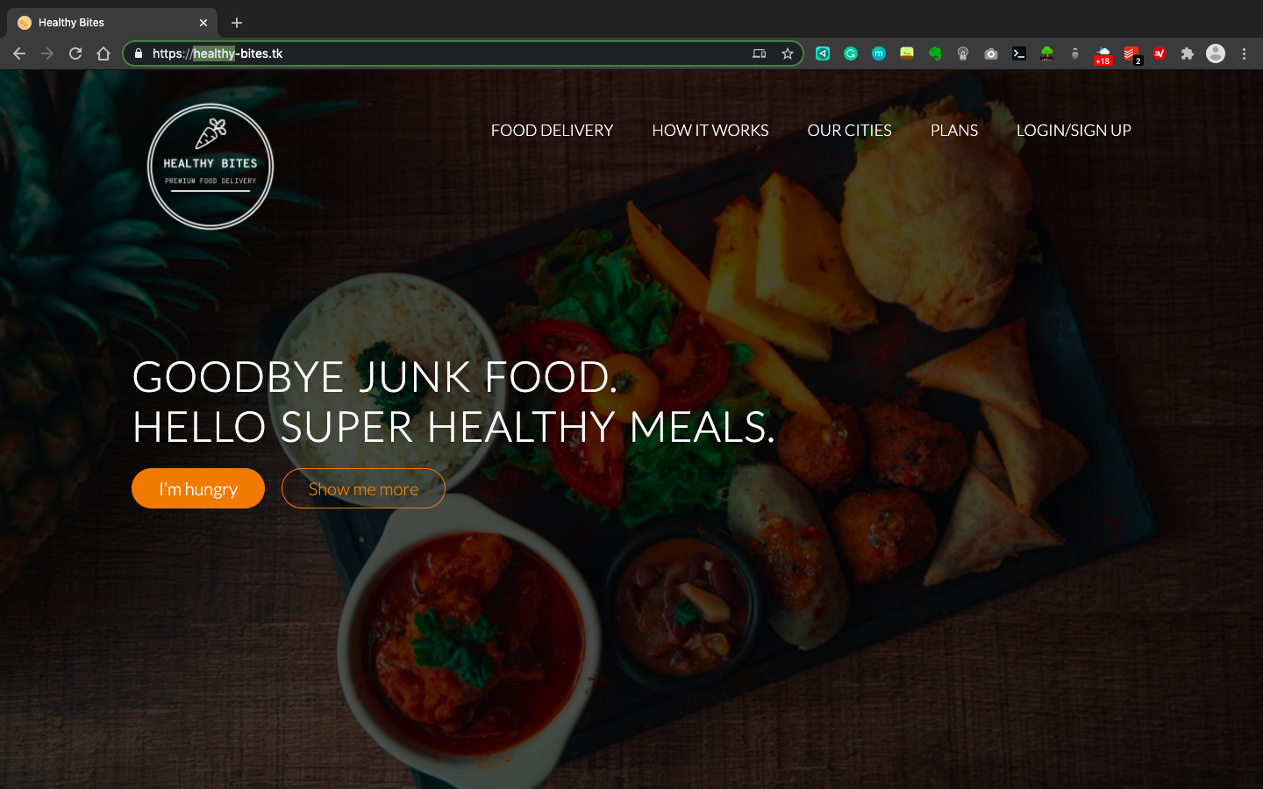



**FUTURE SCOPE**

Static websites will continue to be a cost-effective option for business owners. ..Static website generators will allow web developers to create static websites with user-friendly functionality including faster loading, better security and effective traffic management.

**CONCLUSION**

This project shows how easy it actually is to set-up a static hosting site in AWS using services like S3, Cloud front, route53 and AWS certificate manager.It can be done in few hours and provide a lots of features and file serving can be scaled very easily which is essential for any growing business and also static sites are easier to maintain an update. If someone has a business with a large amount of concurrent web traffic they should always consider making web services static to ensure the maximum speed, scalability, security and efficiency.

**REFERENCES:**

* <https://www.freecodecamp.org/news/a-beginners-guide-on-how-to-host-a-static-site-with-aws/>
* <https://aws.amazon.com/cloudfront/>
* <https://aws.amazon.com/certificate-manager/>
* [https://aws.amazon.com/route53/](https://www.w3schools.com/)
* <https://www.w3schools.com/>
* <https://unsplash.com/>
* <https://generated.photos/>

------------------------------------------xxxxxxxxxx-------------------------------------------